|  |  |  |  |  |  |
| --- | --- | --- | --- | --- | --- |
| **NO** | **COMPONENTS** | **QUANTITY**  **(PCS)** | **ESTIMATED PRICE** | **REAL PRICE** | **INQUIRY** |
| 1 | Arduino UNO | 01 | 850 birr |  |  |
| 2 | Bluetooth Module HC-05 | 01 | 200 birr |  |  |
| 3 | Ultrasonic Sensor HC-SR04 | 01 | 200 birr |  |  |
| 4 | LEDs Orrange(4) ,Red (3) , Yellow(1) | 08 | 8*3 birr |  |  |
| 5 | PVC foam board plastic flat sheet | 04 | 5*200 birr |  |  |
| 6 | Glue Gun sticks | 02 | 2*20 birr |  |  |
| 7 | LM 2577 DC to DC Auto boost buck Convertor 1.25v-30v | 01 | 350 birr |  |  |
| 8 | Resistor 100 ohm | 05 | 5*3 birr |  |  |
| 9 | 65 Jumper Wire. (22M-M,21F-F, 22F-M) | 1 Pack | 65*3 birr |  |  |
| 10 | PCB Strip Board (Dot type) | 01 | 100 birr |  |  |
| 11 | SPST Switch | 01 | 50 birr |  |  |
| 12 | 2 Pin Terminal Connector | 01 | 15 birr |  |  |
| 13 | Micro Servo Motor | 01 | 200 birr |  |  |
| 14 | 9V battery | 01 | 100 birr |  |  |
| 15 | Battery Snap/plug | 02 | 2*50 birr |  |  |
| 16 | L298 Motor Driver Dual Bridge Module | 01 | 250 birr |  |  |
| 17 | Geared DC Motor | 03 | 3*200 birr |  |  |
| 18 | Wheels | 03 | 3*150 birr |  |  |
| 19 | DIY Solar Panel 12V 350mA 4.2W or Similar | 01 | - birr |  |  |
| 20 | MPPT 9V or 12V Solar Charge Controller Module | 01 | - birr |  |  |
| 21 | Buzzer 5V Active | 01 | 100 Birr |  |  |
| 22 | Acrylic Sheet | 02 | - |  |  |
| ***Estimated Total*** | | | ***3599 birr*** |  |  |

**DEVELOPE WATER SUPPLY QUALITY MONITORING BASED ON IOT SYSTEM**

**Required Modules, Parts and Components**

***Notice***: Exclude the two shaded lists

1. Arduino Uno

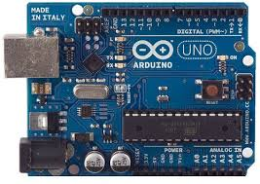

1. Bluetooth Module HC-05

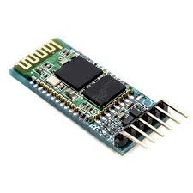

1. Ultrasonic Sensor HC-SR04

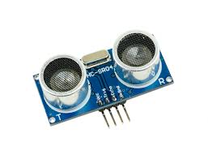

1. LEDs

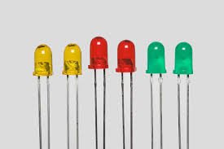

1. PVC foam board plastic flat sheet /For Modeling



1. Glue gun Stick

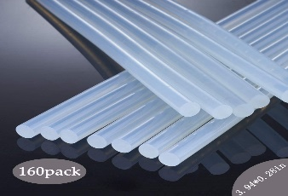

1. DC to DC Auto boost buck Convertor 1.25v-30v

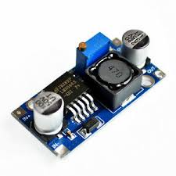

1. 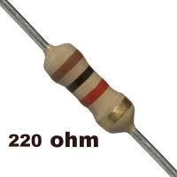Resistor 220 ohm
2. 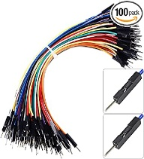65 Jumper wires
3. PCB strip board

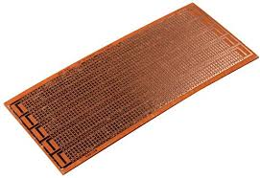

1. SPST Switch

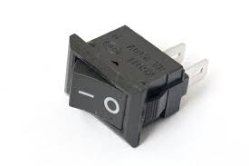

1. 2 pin terminal connector

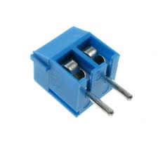

1. Micro Servo Motor
2. 9V battery 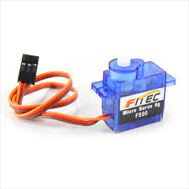



1. Battery Snap/plug

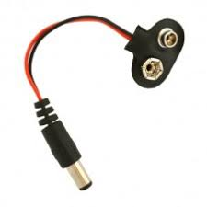

1. L 298 Motor Driver Dual Bridge Module

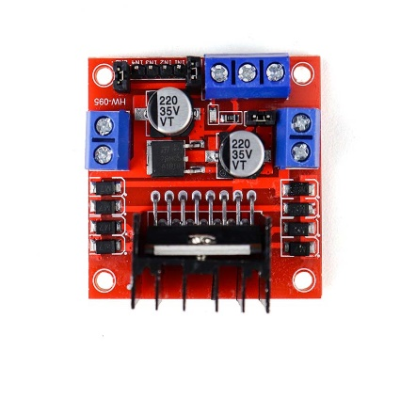

1. Geared DC Motor

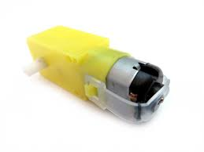

1. Wheels

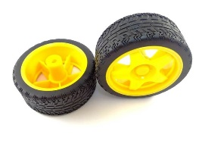

1. DIY Solar Panel 12V 350mA 4.2W or Similar

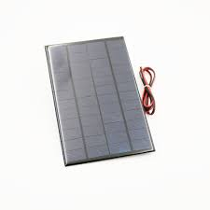

1. MPPT 9V or 12V Solar Charge Controller Module

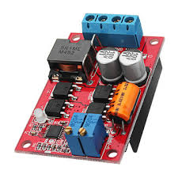

1. Piezo Buzzer

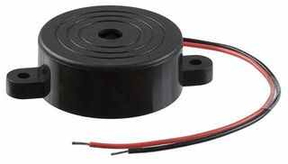

1. Acrylic Sheet

